

A better tomorrow

PART ONE



April 2, 2023

Katelyn Narain

ST10311395

Table of Contents

About 2

Assets 3

Pictures 6

Website Pages and Content 7

### About

**A New Tomorrow**

A New Tomorrow, will be an organization that will help South Africa’s economy in some sort of way by make use of our resources that we already have but don’t use. To develop transformative strategies for town’s and neighborhood’s. Work hand-in-hand with residents, civil society entities, faith-based institutions, business, all levels of government, academic institutions and local change agents to co-create places where people can prosper.

My objective to create healthy eco-systems that lay a foundation for optimal development. Rather than destroying and erasing, places are preserved and given new meaning, providing that brave renovations and restorations have the power to change communities, neighborhoods and cities. A transformed place has the power to transform lives. Through collaboration, we tackle what is wrong and unlock what is strong. Explores the power of abandoned traversing history and narratives through the decrepit walls of long forgotten and lost structures. Not only does this NGO look to the past, it looks towards the future, examining the extraordinary ways lost architecture can be reimagined and repurposed. Abandoned buildings such as old abandoned hospitals, churches, military sites that could be turned into museums, free markets, park, activities for fun and games, shelter for homeless, not only the community but also could be potential tourist attractions.

Abandoned buildings present a unique opportunity for resourceful individuals, communities and governments to repurpose them for a range of different uses. Some of the most common structures include old factories, schools, hospitals and commercial buildings. Many of the buildings have be abandoned for years, and they often fall into disrepair and become eyesores in local communities. However, by making use of abandoned buildings, we can not only restore their beauty but also create practical benefits that can help individuals and communities.

A New Tomorrow will be an organization that makes use of abandoned buildings by doing them up and saving them only to benefit the community around it.

### Assets

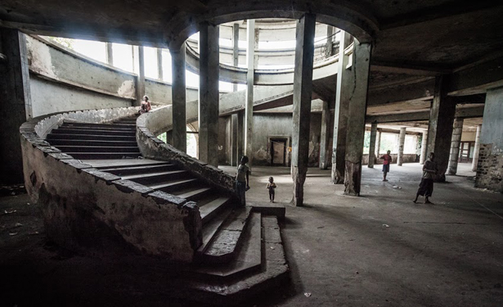

Figure 1: Abandoned Grande Hotel Beira, Mozambique,

n.d. (Source: [Sokhin](https://www.theatlantic.com/international/archive/2013/01/in-mozambique-a-glorious-inn-becomes-a-slum/272533/), n.d. : online)

[Sokhin](https://www.theatlantic.com/international/archive/2013/01/in-mozambique-a-glorious-inn-becomes-a-slum/272533/), V. (n.d) *Abandoned Grande Hotel Beira, Mozambique, n.d.* [online image][Accessed on the 24th March 2023] <https://filmfixers.co.za/2020/05/03/top-10-abandoned-locations/>

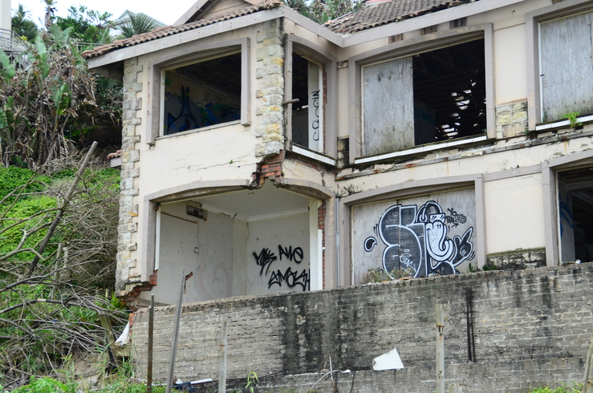

Figure 2: Abandoned Ballito house, Ballito, April 11

2018. (Source: Abrahams, 2018: online)

Abrahams, E. (2018) *Abandoned Ballito house, Ballito, April 11 2018*. [online image][Accessed on the 24th March 2023] <https://northcoastcourier.co.za/106515/abandoned-ballito-house-must-go/>

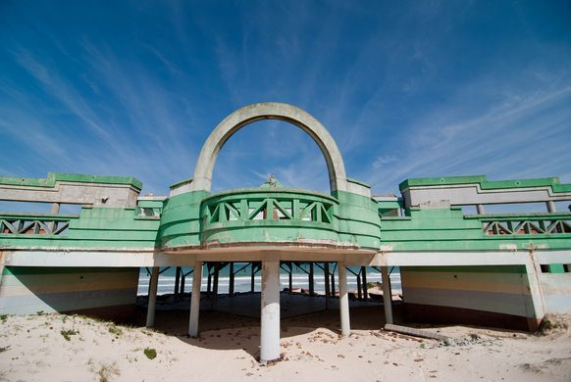

Figure 3: Macassar Beach Pavilion, Cape Town, August

20 2013. (Source: Bischoff, 2013: online)

Bischoff, A. (2013) *Macassar Beach Pavilion, Cape Town, August 20 2013.* [online image][Accessed on the 14th March 2023] <https://www.atlasobscura.com/places/macassar-beach-pavilion>

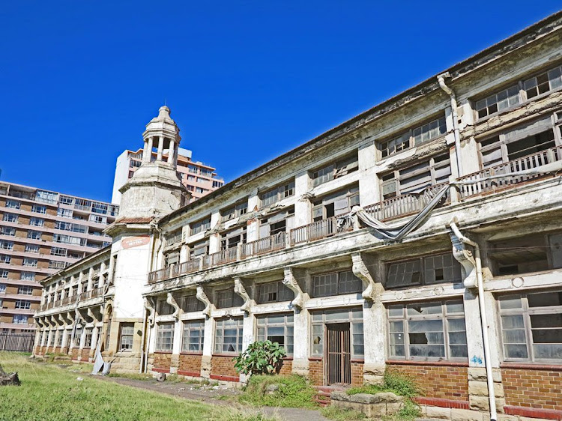

Figure 4: Addington Children’s Hospital, Durban,

October 15 2019. (Source: Botha, 2019: online)

Botha, C. (2019) *Addington Children’s Hospital, Durban, October 15 2019.* [online image][Accessed on the 14th March 2023) <https://www.wantedonline.co.za/art-design/2019-09-17-repurposed-or-ruined-the-lost-grandeur-of-durbans-historical-architecture/>

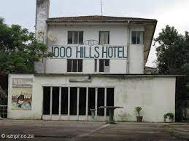

Figure 5: 1000 Hills Hotel, Umgeni, n.d. (Source: KZNPR,

n.d: online)

KZNPR. (n.d) : *1000 Hills Hotel, Umgeni, n.d.* [online image][accessed on the 14th March 2023] <https://kznpr.co.za/drummond-inchanga/>

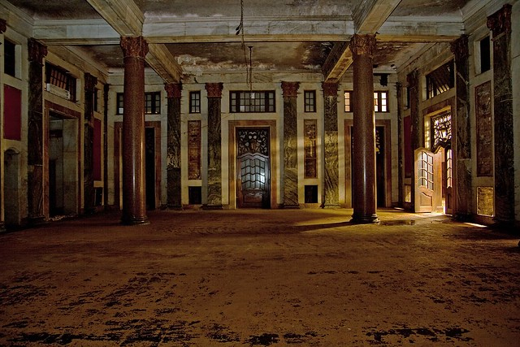

Figure 6: Park Station, Johannesburg, n.d. (Source: Smith, n.d:

Online)

Smith, D. (n.d): *Park Station, Johannesburg, n.d.* [online image][accessed on the 14th March 2023][*https://filmfixers.co.za/2020/05/03/top-10-abandoned-locations/*](https://filmfixers.co.za/2020/05/03/top-10-abandoned-locations/)

### Pictures

#### Logo

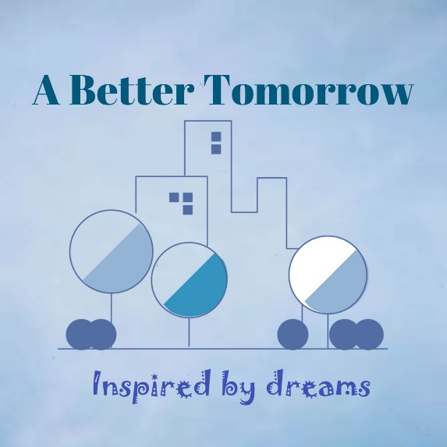designed using LOGO Maker app <https://play.google.com/store/apps/details?id=com.TTT.logomaker.logocreator.generator.designer&hl=en&gl=US>

#### Pictures taken out myself:

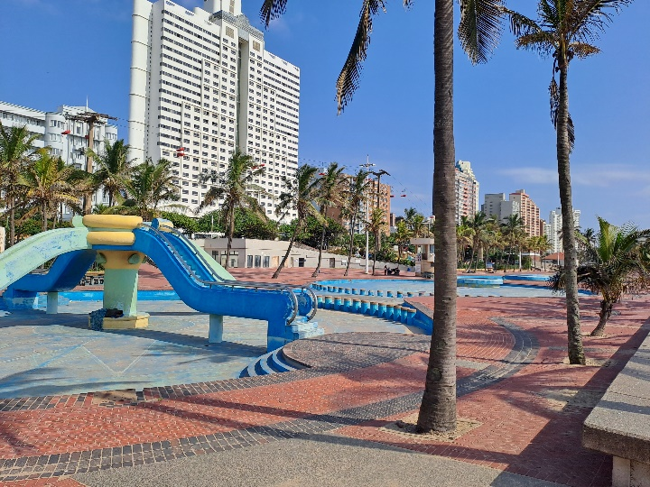

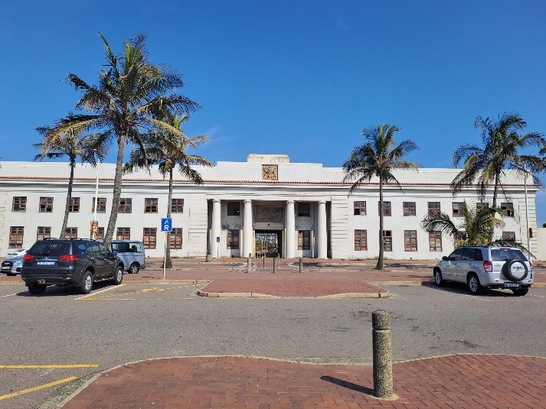

### Website Pages and Content

1. Home
2. Logo
3. Name of organization
4. Slogan
5. Links to other pages
6. Heading (Description:)
7. Summary of main activities of the organization
8. Copyright and year
9. About
10. Logo
11. Organization name
12. Slogan
13. Links to other pages
14. Heading (About us:)
15. Summary about the activity of the organization
16. In Future the pictures of the organization work
17. Gallery
18. Logo
19. Organization name
20. Slogan
21. Links to other pages
22. Pictures of abandoned buildings
23. Name and location of abandoned buildings
24. Sources of imagine
25. Contact
26. Logo
27. Organization name
28. Slogan
29. Links to other pages
30. Contact details for: telephone, cellphone, email, Instagram, Facebook
31. Services
32. Logo
33. Organization name
34. Slogan
35. Links to other pages
36. Description on our ideas
37. Donate
38. Logo
39. Organization name
40. Slogan
41. Links to other pages
42. Bank details